Application 1

Food Calorie Estimation from Images



Domain 🡪 **Deep Learning AI Prediction**

Input to the model (food images) 🡪 Predicts (predict the

food item) 🡪 Call to action (display calorie information)

Application 2

Diabetics Prediction

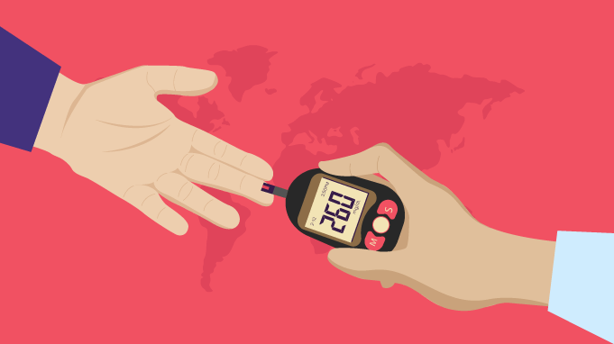

Domain 🡪 **Machine Learning AI Prediction**

Input to the model (glucose level, blood pressure, age, BMI)

🡪 Predicts (diabetic or non-diabetic) 🡪 Call to action

(professional medical advice )

Application 3

YouTube Bad Comment Identification

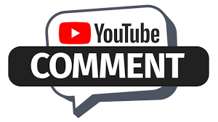

Domain 🡪**Natural Language Processing AI Prediction**

Input to the model (dataset of inappropriate comments)

🡪 Predicts (bad or not bad) 🡪 Call to action

(remove bad comments automatically and send warning to the user who comments)

Application 4

Demand Forecasting for Retail inventory



Domain 🡪**Time Series Analysis AI Prediction**

Input to the model (historical data, product info, seasonal data, promotional data, customer data, external data) 🡪 Predicts (forecast future product demand) 🡪 Call to action

(Optimized inventory level, adjust procurement strategies such as stock availability, minimize stockouts and avoid overstock situation)

Application 5

Voice Warning System for ATM Occupancy

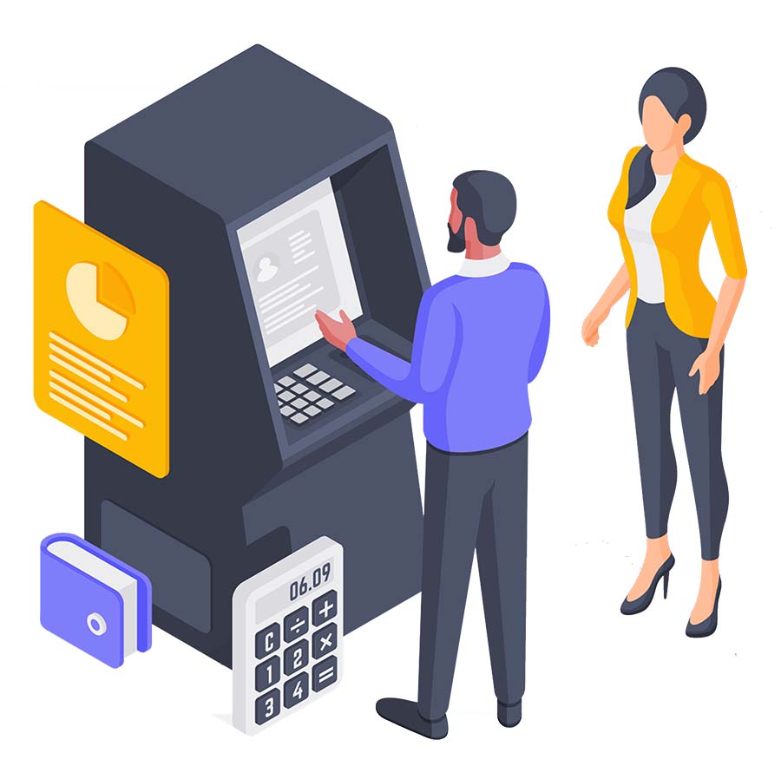

Domain 🡪**Deep Learning AI Prediction**

Input to the model (image, voice data)

🡪 Predicts (detect more than one person inside ATM booth) 🡪 Call to action

(play a pre-recorded voice warning to alert individuals about the violation of ATM safety protocols)